Bromley Beacon Academy
Orpington Campus
Bromley Campus

Labour Market Information

Labour Market Information (LMI) is an important tool to help us identify which jobs are on the increase and where we identify jobs that will pay us the best wage!

The information below will provide you with details of the local picture in the London Borough of Bromley.

This information is based on the latest statistics and will be updated on an annual basis.

It is estimated that jobs in London will grow from 2016 at an annual average rate of 0.78 per cent a year, equivalent to 49,000 jobs, to reach 6.907 million in 2041.

Jobs in the professional, real estate, scientific and technical sector are expected to grow strongly, accounting for over a third of the total increase expected in London to 2041. Strong employment growth is also expected in the administrative and support services, accommodation and food services, information and communications sectors, education and health sectors. The six sectors account for nearly three fifths of the expected total London increase in jobs to 2041.

The annual growth rate in Bromley is almost identical with that for London as a whole at 0.77 per cent a year.

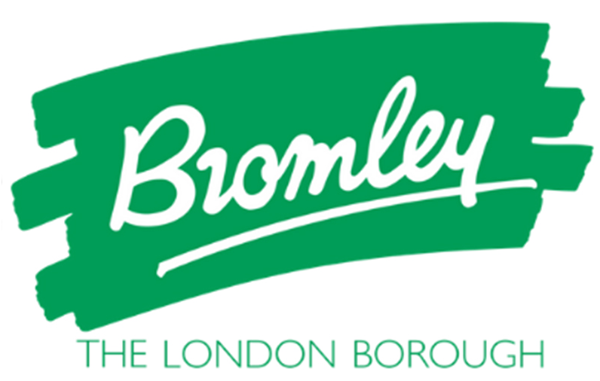
Useful facts & Figures

- Bromley’s economy is comparable in scale to Oxford, Reading and Southampton
- Average earnings by residents in Bromley are £612pw (compared with London £736.50; UK £586.50)
Bromley borough has;
77 primary schools
19 secondary schools
6 special schools

Economically active (16+) 167,400

The population in Bromley is 331,100
In employment – 159,900
Employees – 135,000
Self-employed – 24,700
Unemployed – 6,600
11.4% self-employment in Bromley (compared with UK 10.7%)
Unemployment claimant rate (Nov 19)2% (compared with London 3%; UK 2.9%)

Average house price £486,000

Employee Jobs by Industry

Business Area | Number of jobs  Bromley (2018) | Bromley  % | London  % | Great Britain  %

Wholesale & Retail | 17,000 | 15.9 | 12.0 | 15.2
Health & Social Care | 17,000 | 15.39 | 0.3 | 13.2
Administration | 12,000 | 11.2 | 10.9 | 9.1
Education | 11,000 | 10.3 | 7.4 | 8.9
Science & Technology | 8,000 | 7.5 | 13.7 | 8.7

Employment by Occupation

Business Area | Number of jobs  Bromley (2018) | Bromley  % | London  % | Great Britain  %

Managers, Directors & Senior Officials | 20,200 | 12.7 | 13.0 | 11.1
Professional Occupations | 40,400 | 25.2 | 26.3 | 21.0
Associate Professional & Technical | 33,200 | 20.8 | 18.8 | 14.8
Administrative &Secretarial | 19,400 | 12.1 | 9.0 | 9.8
Skilled Trade Occupations | 9,900 | 6.2 | 7.0 | 10.0
Caring, Leisure & Other Service Occupations | 13,200 | 8.3 | 7.0 | 9.0
Sales & Customer Service Occupations | 8,100 | 5.0 | 5.6 | 7.3
Process Plant & Machine Operatives | 5,900 | 3.7 | 4.6 | 6.3
Elementary Occupations | 9,000 | 5.6 | 8.2 | 10.3

To find out more information about jobs in our local area, go to the Careers Coach on our website where you will find lots more information! Click
HERE to take you straight to the website.

